Liquid Intelligence
A River of Infinite Insights

Intelligence must flow and adapt, maintaining cognitive flexibility—the ability to think fluidly across domains, synthesize disparate ideas, and apply knowledge in novel contexts. Liquid intelligence represents the capacity to navigate uncertainty, recognize patterns in unfamiliar situations, and apply critical thinking as circumstances change.
It begins as data: facts expressed using numbers. words and images that are then associated with entities, people, objects, places and activities.
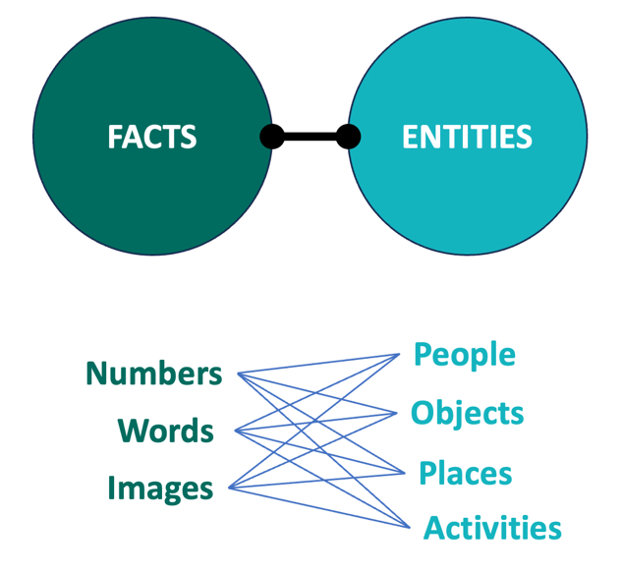
Facts are accurate once, at the moment-of-record; therefore, facts havea historical record of time-sensitive values. Entitles are also constantly eevolving. Data is a hyper-relational, constantly. evolving network that flows from multiple sources (tributaries).
We institute Critical Learning to filter what is accurate, truthful and relevant to identify Meaningful Knowledge. When this knowledege s associate with consequences it is intelligence, liquid intelligence. Simply stated we Know the truth, faster!

Intelligence that flows and adapts rather than remaining fixed or static. This concept emphasizes cognitive flexibility—the ability to think fluidly across domains, synthesize disparate ideas, and apply knowledge in novel contexts. Unlike crystallized intelligence (accumulated facts and skills), liquid intelligence represents the capacity to navigate uncertainty, recognize patterns in unfamiliar situations, and reorganize thinking as circumstances change. It's intelligence that moves like water, finding new paths rather than following predetermined channels.

